Assignment 14

Task 1

Ask AI to generate a simple HTML homepage for a "Student Info
Portal" with a header, navigation menu, and footer.
Expected Output:
● HTML code with <header>, <nav>, <footer>.
● Clean indentation, proper tags, and comments.

Code:

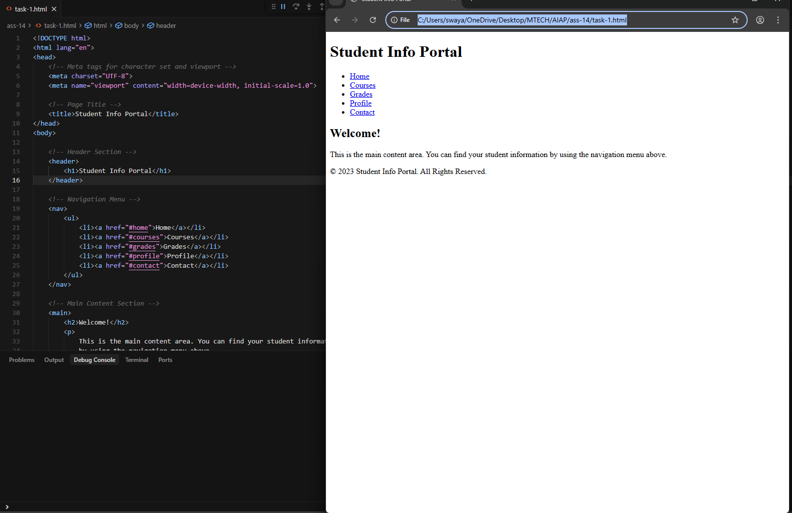

Task 2

Use AI to add CSS styling to Task #1 homepage for:
● Responsive navigation bar.
● Centered content section.
● Footer with light gray background.
Expected Output:
● HTML + CSS combined.
● AI explains how CSS classes apply.

Code:

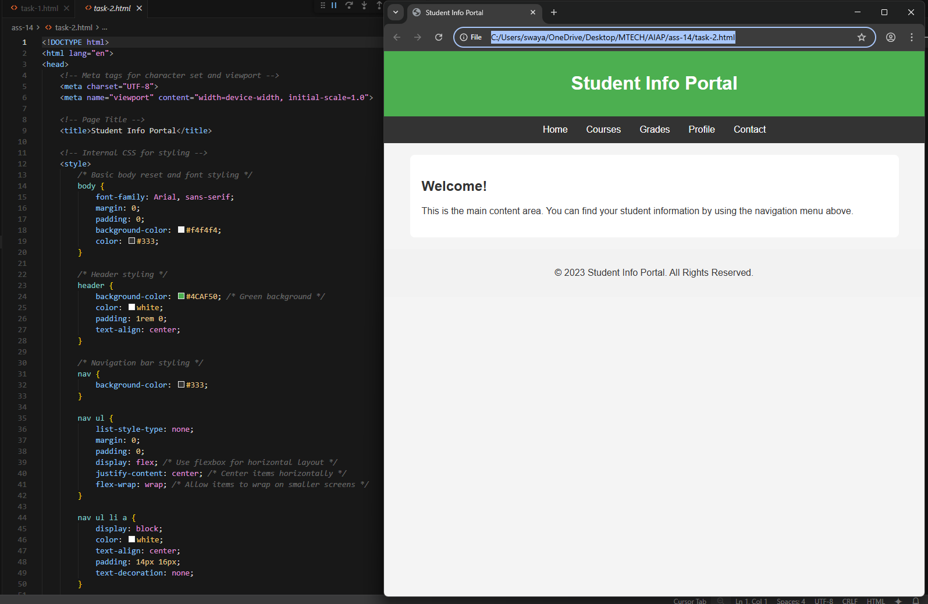

Task 3

Prompt AI to generate a JS script that validates a simple login form (non-empty username/password).
Expected Output:
Working on submit JS validation.
Clear error messages if inputs are empty.

Code:

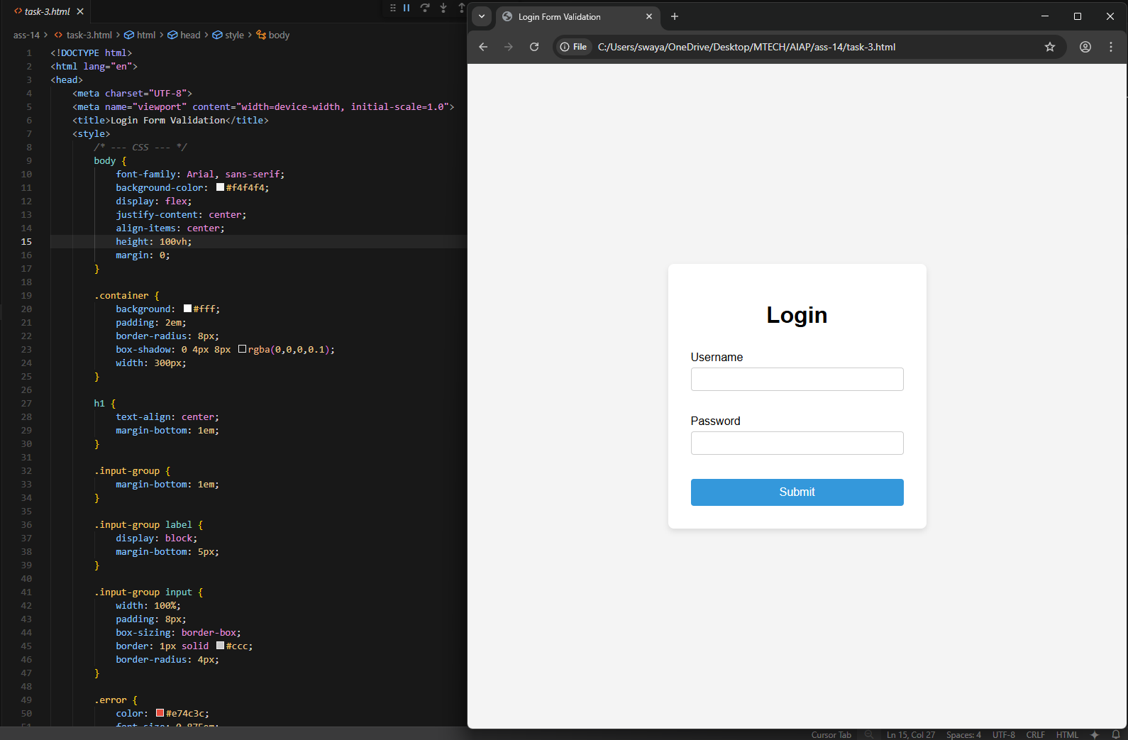

Task 4

Ask AI to generate a Flask app that serves the HTML form (Task #3) and prints the username on successful login.

Code:

